Server

D:\Program Files\apache-jmeter-2.9\bin\ jmeter.bat

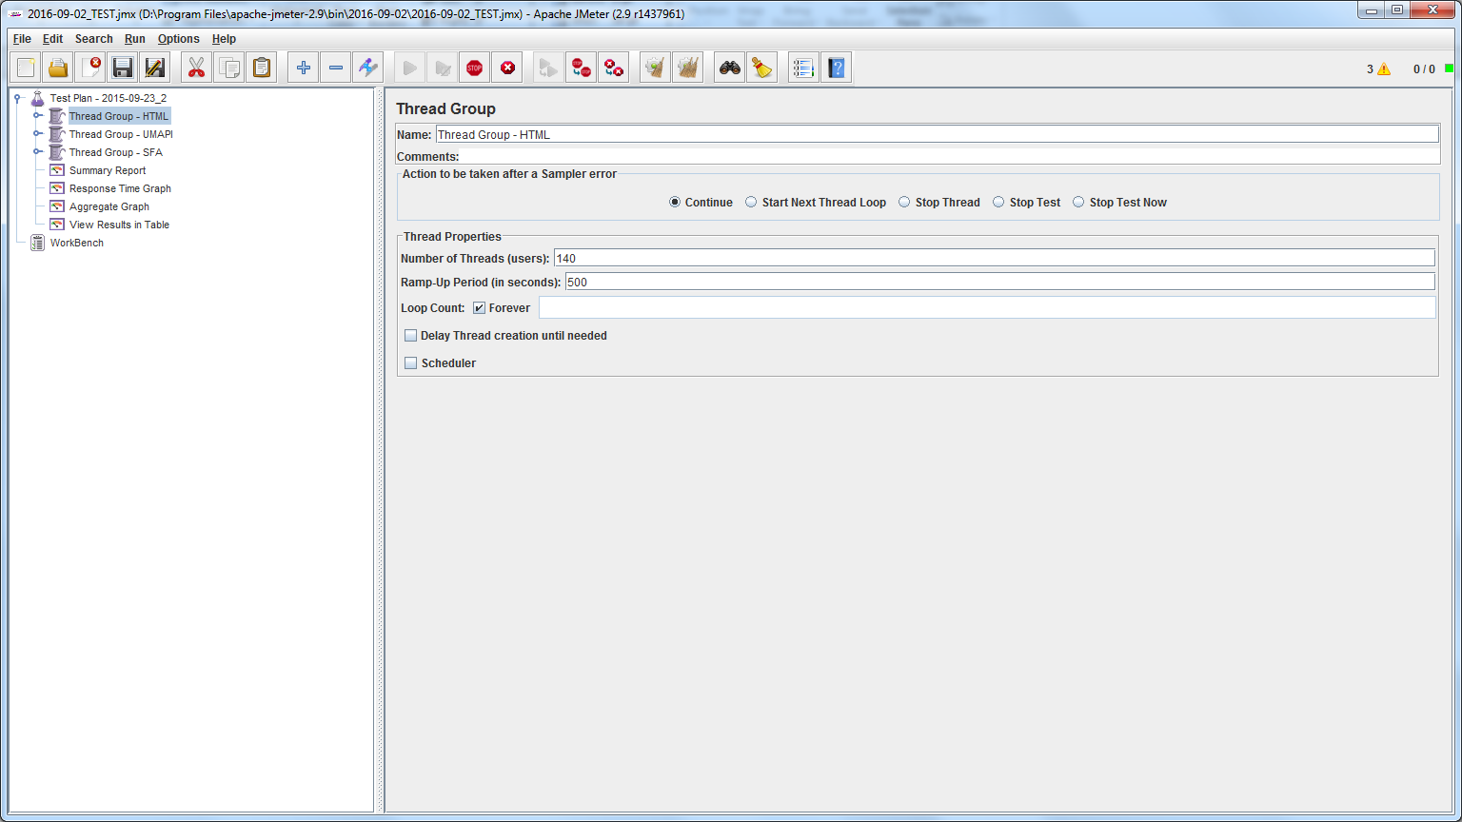

To Run All

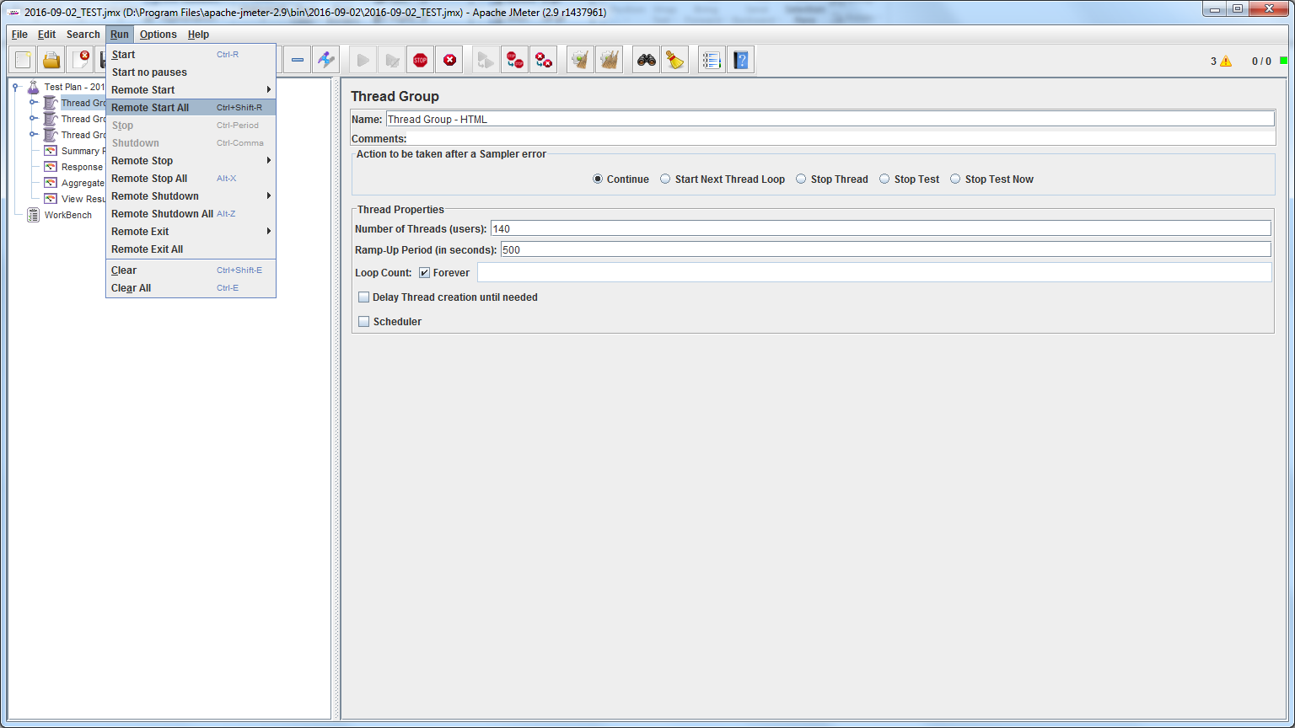

Run Specific

